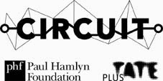
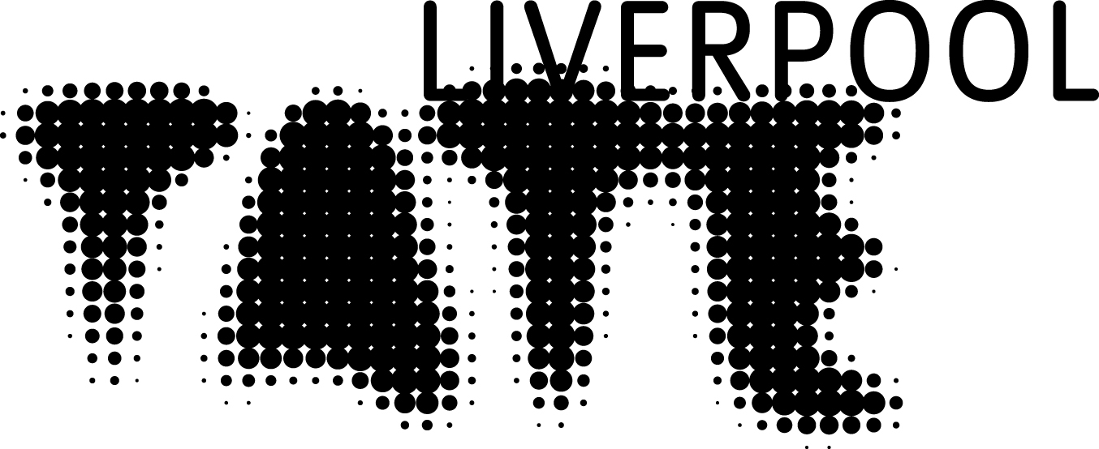

The Creative Forum application form
Sessions from 19 October

Calling all young creative peoples based in the North-West! Are you aged 15-25? Are you looking to develop your artistic practice in a friendly and professional environment? Then complete the below application form alongside an image of an artwork or idea you would like to develop and send to alex.dodgson@tate.org.uk.

Please note: all submissions will be considered for the programme. However, due to the limited size of this new project, any applicants that are unsuccessful on this occasion will be placed on a waiting list for immediate consideration next time around and will receive updates and information about the programme in the near future.
If you are under 18 please also complete the below consent form and attach this alongside your application.

*By submitting this application, you give your consent that Tate Liverpool can directly contact you via telephone or email and that we will store your information in our database specifically for use in ‘The Creative Forum’ project.

Name: |  | Date of Birth:
Phone: |  | Email Address:

A short statement about your artwork to date: (200 words max)

What do you want to learn in the sessions?: (100 words max)

The Creative Forum Consent Form

I …………(full name)……………... have read and agree to the Terms and Conditions of the Blueprint Open Call and permit my Son/ Daughter ……………(full name)…………… to submit their application for The Creative Forum project 2014 under the conditions stated.

Terms and Conditions

- By submitting your work to the Tate Collective Liverpool either via e-mail, the Tate Collectives website or post, you declare to Tate that the image is your own original work which will not infringe the copyright or any other rights of a third party.

- Entrants must ensure that any third party copyrighted material contained in a submitted work has already been cleared with the copyright holder and provide a copy of the clearance to Tate if requested.

- All videos or images submitted to Tate Collective Liverpool either via e-mail, the Tate Collectives website or post may be displayed on Tate’s website, Tate’s online channels and as part of the Tate Collectives website, and images may be used in online and offline material to promote the Tate Collectives projects. All entrants give Tate a non-exclusive, worldwide, royalty free, irrevocable licence in perpetuity to use their images for all such purposes.

- If your artwork is to be brought into the gallery then you will take full responsibility to transport the artwork to and from the exhibition space at your own expense.

- Tate will not accept responsibility for any loss and/or damage of your artwork.

- Any work submitted after the deadline will not be considered.

- The artist must be between 15 - 25 years old by October 1st 2014 to be included in the programme.

- Tate will only use your data to administer the call for submissions and won’t pass that information onto third parties without your consent.

- The Board of Trustees of the Tate Gallery reserves the right, at its sole discretion, to choose to include or not include a submission for use in the programme. Any imagery which is intended to have as its primary purpose an organised political, commercial, promotional or campaigning purpose may not be deemed to be of primary artistic intent and may therefore not be selected.

- Tate is not responsible for monitoring, verifying or disproving the identity of any contributor. Any opinions, statements and third party content are those of the respective artist(s), authors(s) or distributor(s), and not of Tate.

- Tate does not endorse any such opinion, statement or other material posted in any image.

- Tate may at some point wish to further reproduce or store, by any means or any media some of the content posted. In order to facilitate this, by submitting your work you agree to grant Tate a non-exclusive, worldwide, perpetual royalty-free licence to reproduce, modify, edit, publish and distribute the content you submit.

- Tate reserves the right, at its sole discretion, to choose to include or not include such submission for any such use.

- You must own all the rights to any material that you submit. In no event may you submit any third party material protected by copyright without having obtained the permission of the copyright owner. You agree that if you do submit such material, you must state the source and provide a copy of the permission to Tate if requested.

-You may not submit any material that defames any person, invades their privacy, infringes their trademark or other rights, or which is otherwise unlawful.

-If you are under 18 you must obtain the consent of a parent or guardian to submit your work on these terms and conditions and you confirm that you have done so.

Please see our copyright terms and conditions http://www.tate.org.uk/about/who-we-are/policies-and-procedures/website-terms-use/copyright-and-permissions for restrictions on reproducing content on our website.

- By submitting your work to a Tate Collectives online project via e-mail, the Tate Collectives website or post, you are deemed to have accepted the above terms and conditions.

Date:
Contact phone number:

